Data Structure and Algorithm Assignment 1:

Variable: A variable in programming is a named place in memory that stores a value you can use and change while a program runs.
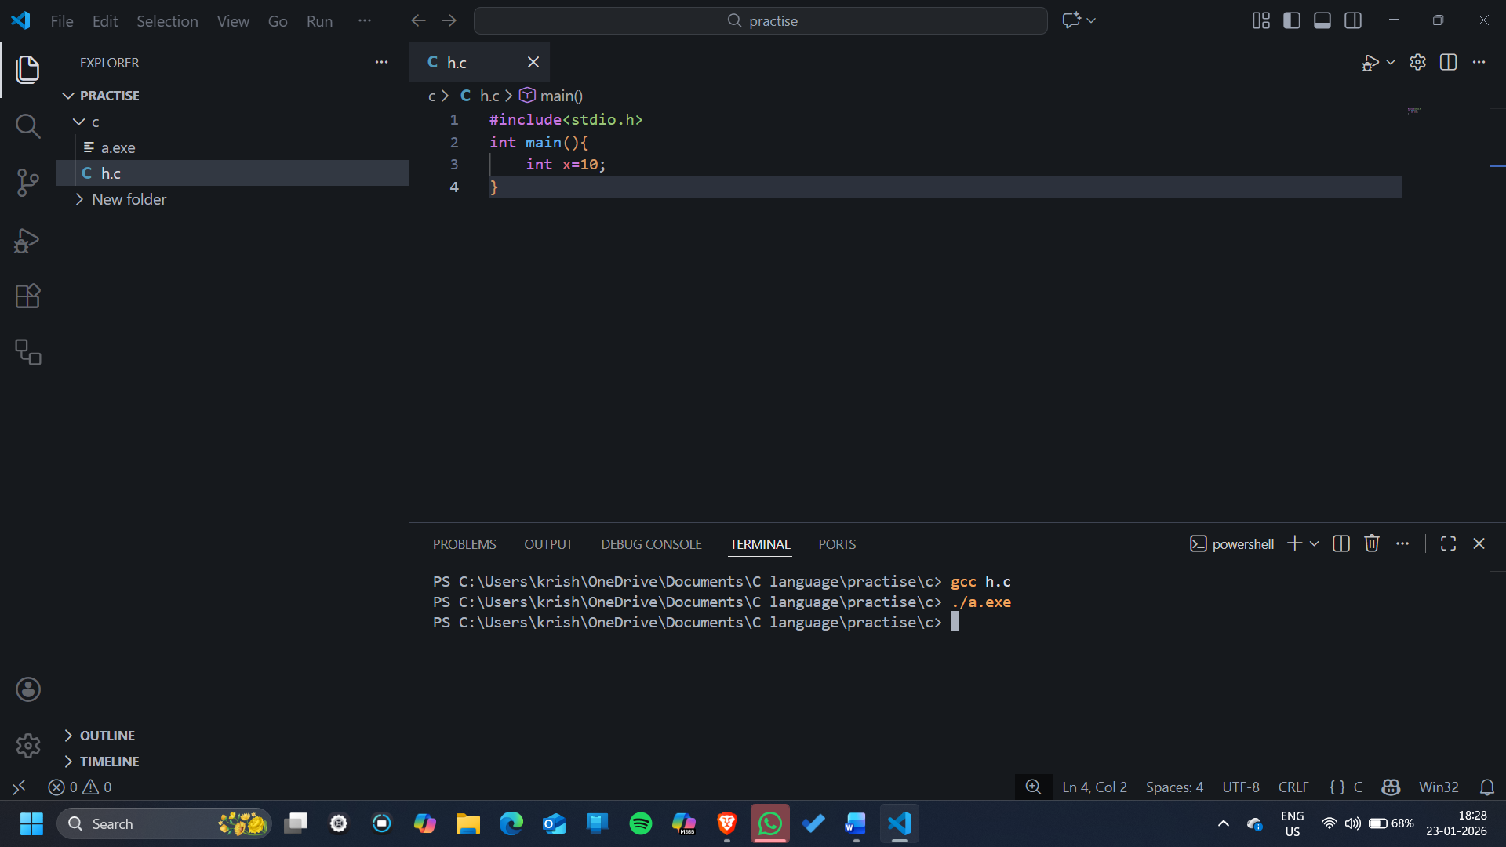
Here,
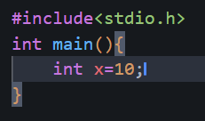
“x” is a variable of int datatype and its assigned value is 10.

Like that there is a variable pointer what makes it special is that a pointer stores an address (the location in memory of another variable).
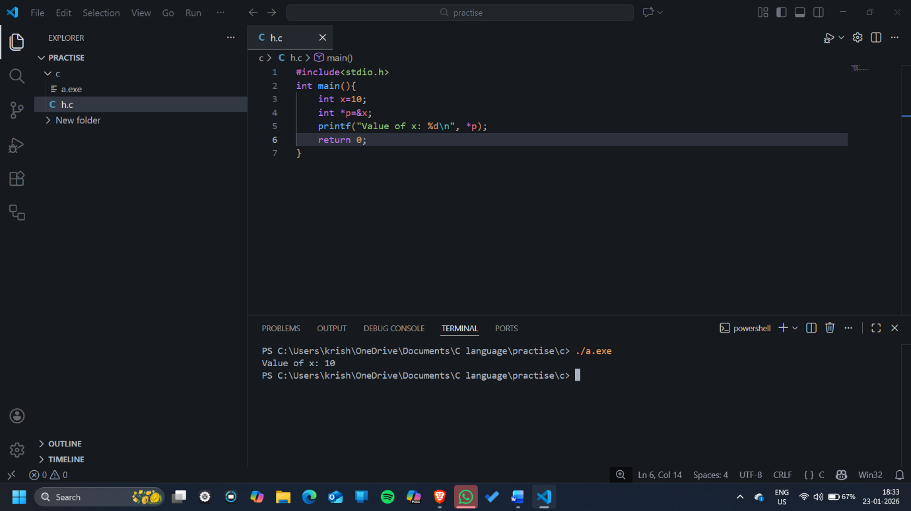

Datatype: A data type tells the computer what kind of data a variable can hold and how that data should be stored and used.
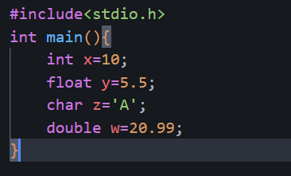
Here, x is a variable of datatype int x and assigned value 10,
y of datatype float with assigned value 5.5,
z of datatype char with assigned value of A,
and w of datatype double with assigned value 20.99.
There are user defined datatype like structure, class etc.
Then there is distinction or type like Primitive and Non-Primitive Datatype.
    - Primitive datatype includes Float, Int, Char etc. basic datatypes and non-primitive include Array, List, File etc.

Basic Input and Output:
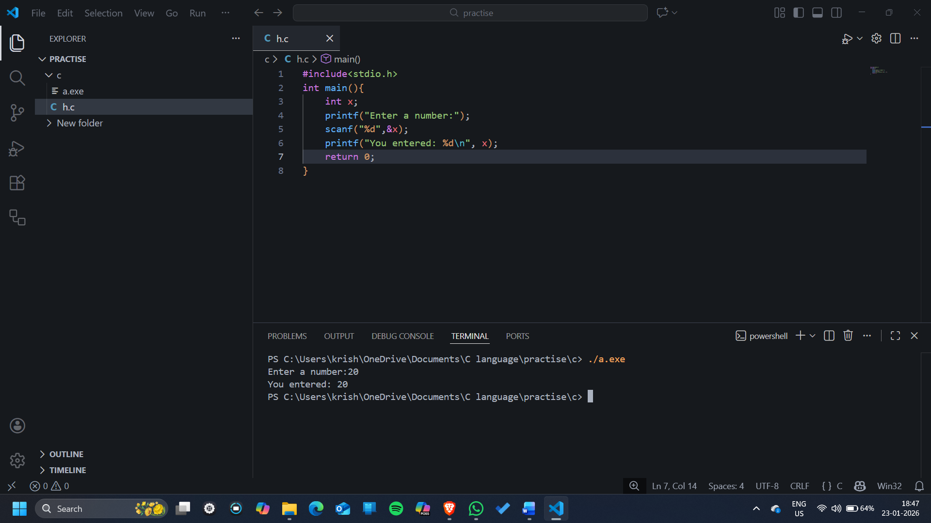
Here, we prompt the user to enter a number with the help of function “printf” provided by library “stdio” which stand for standard input output and take input using “scanf” also provided by stdio and then again use scanf to show output using printf.
Code:
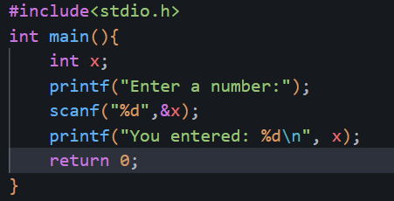
Output:
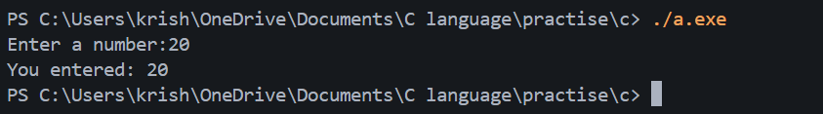

Operator: Operators are symbols that tell the computer to perform an operation on values or variables.
Main type of Operator:
- Arithmetic Operator
- Relational Operator
- Logical Operator
- Assignment Operator
- Increment Operator
- Bitwise Operator
- Ternary Operator
Code:
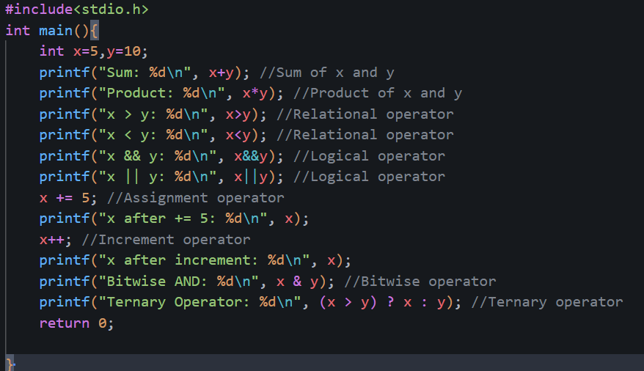

Output:
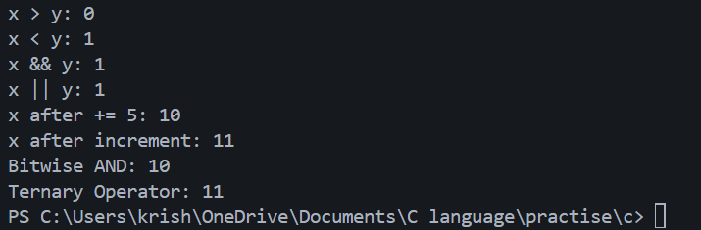

Conditional Statement: Conditional statements are statements that execute different blocks of code depending on whether a condition is true or false.
Example: Ternary Operator, Switch and if-else.
Code:
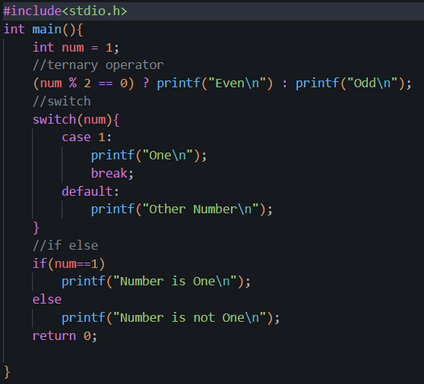

Output:
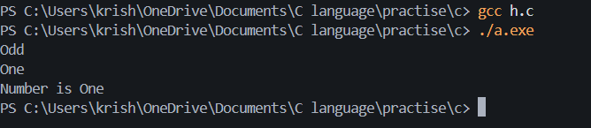

Loop: A loop is a programming statement that repeats a block of code as long as a given condition is true.
Example: for loop, while loop and do-while loop.
Code:
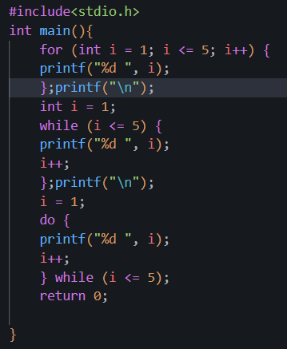
Output:
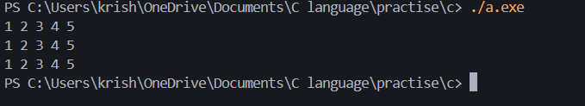

We use for loop when we know the number of iterations, while loop when we don’t know the number of iteration and do-while loop when at least we want the loop to run (others also can be used).

Function: A function is a block of code that performs a specific task and can be reused whenever needed.
Type of Functions:
- Built-in function
- User defined function
  - Function with no arguments and no return value
  - Function with arguments but no return value
  - Function with no arguments but returns a value
  - Function with arguments and returns a value
Code:
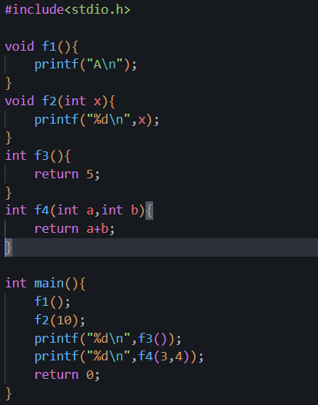

Output:
